# **Ha Kyoto Omu Kairirizi**

Runyoro - Rotooro: At the fireside in the evening by S. T. MANYINDO illustrated by A.W.R. MCCRAE AND ALAN JARMAN

This book has been recommended for use in Primary Schools and has been read and recommended by the Runyoro-Rutooro Language and Literature Committee.

# **Ha Kyoto Omu Kairirizi**

kikahanditkwa S. T. MANYINDO 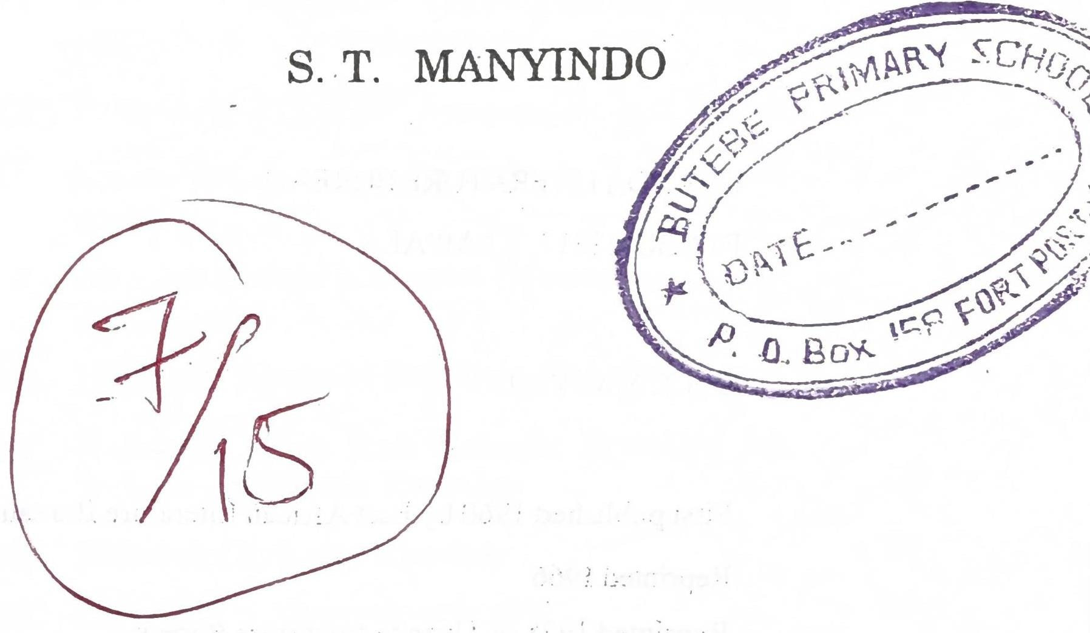

UGANDA LITERATURE BUREAU

KAMPALA 1978

# **UGANDA LITERATURE BUREAU**

P.O. BOX 1317, KAMPALA (C) S.T. MANYINDO

First published 1960 by East African Literature Bureau Reprinted 1966 Reprinted 1978 by Uganda Literature Bureau

# **EBIRUMU**

Orupapura I. Nkooku Amagezi Gaahikireho Buli Muntu Weena ..... 1 II. Habwaki Enzikeeri Obu Bagikwata Eteera Ekifuba Kyayo n'Amapapa ..... 3 III. Omwisiki "Kyakyo" Ayagonzibwaga Muno ..... 5 IV. Habwaki Ebikere Bitakira Kubingwa Aboojo ..... 8 V. Nkooku Entale n'Empisi Byaizire Kuganjana ..... 11 VI. Habwaki Abaisiki Bataliire Enkoko ..... 13 VII. Habwaki Engo Buli Kasumi Ikwatira ha Rubaju rw'Emoso Rwonka ..... 18 VIII. Habwaki Enkoko Ekooka ..... 21 IX. Omuhiigi n'Akanyamankogoto ..... 23 X. Habwaki Ensere Ziikara Omu Maizi ..... 26 XI. Rwakaikara Omusohi w'Encu Kandi Omufu w'Amaiso ..... 28 XII. Ekyoma Ekyasaaga Oburo Kyonka ..... 31 XIII. Juma n'Abakazi Abadoma ..... 33 XIV. Omunyoro Tindukwetegereza ..... 39 XV. Ekisura Ekyaibirwe ..... 42 XVI. Omukaikuru n'Ente Ye (Oruganikyo rw' Omukaikuru n'Ente Ye) ..... 45 XVII. Obucwangya Bwingi Bukafeereza Katabaazi Enjonjo ..... 48

# **I**

## **NKOOKU AMAGEZI GAAHIKIREHO BULI**

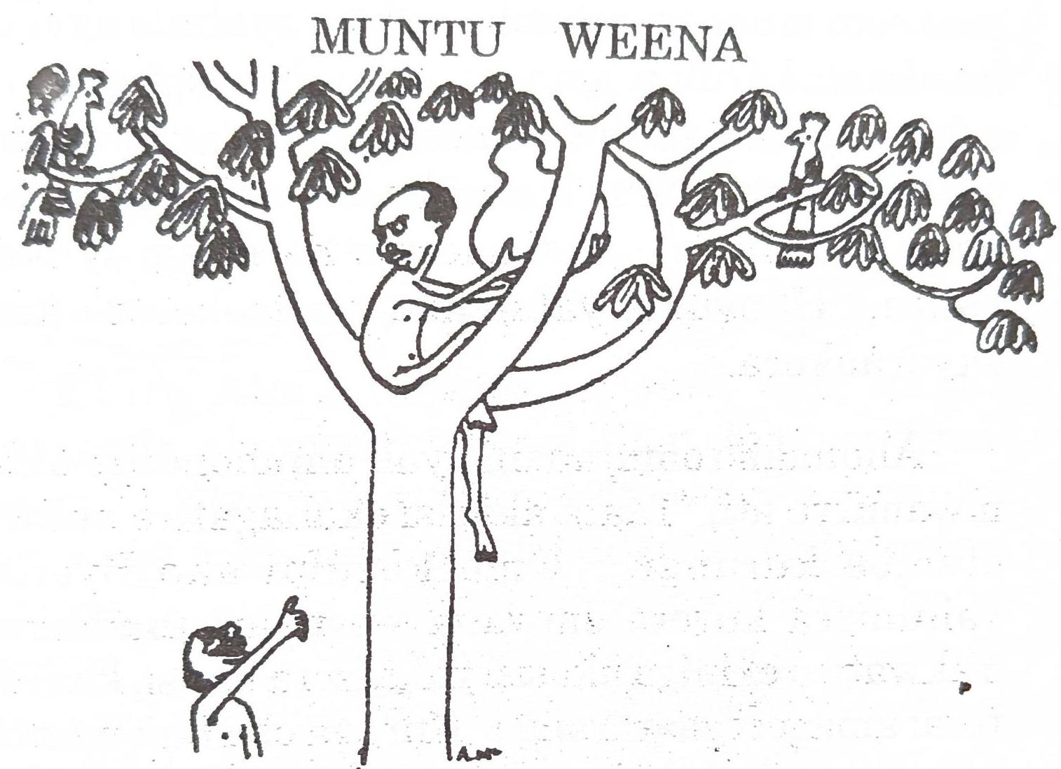

Omu biro bya ira omunsi ya Tooro hakaba harumu omusaija ayayetwaga Byensi. Omuntu onu nuwe wenka akaba aina amagezi ga buli mulingo abantu abandi baali batalaina magezi. Ekiro kimu abantu bakamwizira okubaha amagezi, baitu uwe atagonze kubagambira ekintu kyona; na habweki bo nukwo kucwamu kumurwanisa. Kinu kikabiihiza muno Byensi, nukwo na uwe kucwamu okutwara akasisi akaakaba ayahwiremu amagezi akakasereka hara.

Mutabani we obu yarozire ise naagenda wenka omu kisaka kusereka akasisi, yatiina. Yateekereza ati rundi ise naagonza kweita. Byensi obu yagenzire hara muno omu kisaka akarora omuti mukooto muno yagutemba nukwo ayahule akasisi ke akaali karumu amagezi omu mataagi g'omuti - eruguru. Baitu habw'okulemeera kw'akasisi, obu yalengereho muno kutemba omuti kuhika ha iguru, yalemwa. Akalemerwa ha itaagi ly'okubanza. Hanyuma yatandika okuteekereza kiki ekyaraakora.

Ahonaaho omutabani ayali amuhondiire akamwamirra ati, "Taata akasisi okahagatire nukwo otembe kurungi." Omu kasumi ako Byensi yahunirra kurora omwana we naamuhanurra. Yakwatwa ekiniga akasisi yakateera hansi, kaayatika; amagezi gaararanga. Kuruga obu buli muntu weena gaamuhikaho.

# **II**

## **HABWAKI ENZIKEERI OBU BAGIKWATA ETEERA EKIFUBA KYAYO N'AMAPAPA**

Omu biro bya ira muno, haabahoga okusandaara kw'amaizi. Enyanja zaaboogaga muno, amaizi gamira abantu bahwerekerra. Abaasigarahoga baalengahoga kugenda kwikara mu bicweka ebiri hara n'enyanja.

Ekiro kimu, omusaija omu obu akaba naagenda, akarora ekinyonyi kimu ekyetwa "Enzikeeri." Ekinyonyi kinu kiikara mu nyanja. Omusaija yakigamba ati, "Abantu baingi bahwerekeriire baisirwe amaizi habw'okubooga kw'enyanja." Enzikeeri yamugarukamu eti, "Gambira abantu babyale emikindo mu nkarra ha myegeego y'enyanja okugyeehinguliriza. Emikindo obu erikura eritanga amaizi kucwa gakasandaarahoonahoona omunsi." Omusaija yatwara amagezi ganu yagamanyisa abantu boona. Na bo nukwo baakora, baabyara emikindo okwehinguliriza enyanja zoona. Obu enyanja zaaboogaga amaizi tigaasoboraga kucwa gakagenda okwita abantu.

Enzikeeri na yo ekanihira ngu abantu na bo tibalirema kugikoonyera kakuba habaho ekigigweriire. Eky'omugisa mubi abantu bakeebwa

amagezi enzikeeri yabahaire. Tibaagikorra amakune. Buli kasumi yaijaga ha bwerre erugire omunyanja habw'okwalika amahuli gaayo, hanyuma ekiro ekimu abantu baagikwata, baagiita, baagirya.

Nahabweki nikyo ororra omuntu obu akwata enzikeeri, yo ebanza eteerateera ha kifuba kyayo n'amapapa, obu eba neekungana eti, "Nyowe habw'okubaha amagezi mukeejuna kwitwa okusandaara kw'amaizi nikyo inywe mumpiigira?"

# **III**

## **OMWISIKI "KYAKYO" AYAGONZIBWAGA MUNO**

Ira hakaba haroho omusaija azaire muhara we murungi muno. Abasaija baingi abaamuroraga, baamwegomba kumuswera. Omwisiki habw'okusemera muno bakamurukirra ibara "Kyakyo". Ekiro kimu, abasaija basatu bakaija owaabu omwisiki okweranga. Ise Kyakyo yabagambira ati, "Tindukugonza kusweza omwana wange Kyakyo habwokuba nankoonyera muno kandi nuwe nyina wenka."

Baitu abasaija abo basatu, abaswezi, bakeesengereza muno ise Kyakyo okubaha muhara we bamuswere, habwokuba akaba abacwire muno omutima. Nubwo Ise Kyakyo yaikiriize, baitu yabagambira ati, "Inywe inywenka niinywe mukomeho omu ou araaswera Kyakyo, habwokuba abasaija basatu inywena timurukosobora kuswera omukazi omu." Abasaija bakalemesibwa kukomamu omu omuli bo, habwokuba boona baagonzaaga muno Kyakyo. Abaswezi bakamanyisa ise Kyakyo bati, "Itwe itwenka kiremiire kukomaho omuntu omu ou araaswera Kyakyo." Nubwo ise Kyakyo yabamanyisize ati, "Hati mugarukeyo, ndibeeta kiro kindi."

Obu baamazire kugenda ise Kyakyo yagambira omuhara ati, "Byama omu kitabu kyawe oyesweke, osisane nk'omuntu afiire. Nyowe kantumire bwangu abasajja bali abaizirege nibagonza kukuswera mbamanyise nti 'muhara wange afiire mwije tumuziike'." Bambi Kyakyo nukwo yakozire nka ise oku yamuragiire, yayeswekerra weena.

Hanyuma, ise yatuma bwangu kweta abasajja abaagonzaaga kuswera muhara we kwija. Omukwenda akabanza kuhika omb'omusaija w'okubanza ayayetwaga Byangireeka. Yamugambira byona ebi akaba atumirwe ise Kyakyo. Byangireeka obu yahuliire ebigambo ebi yatumirweho, yaseka kwonka, yagamba ati; "Nyowe hati habwaki nfeerwa amaani gange kugenda kuziika. Omwisiki namugonzaaga ali mwomeezi nukwo mmuswere. Kandi hati ningasirwa ki?" Omukwenda obu yarugire owa Byangireeka yagenda omb'owa kabiri ayayetegwa Tinganya. Obu yamumanyisize byona ebya ise Kyakyo yamuragiire, na uwe ataganye kufa kwa Kyakyo, akasisana nk'ibara lye. Yabinga omukwenda amurugire omuka.

Nubwo caali omukwenda yairukire yagenda yahikaho omusaija owa kasatu ayayetwaga Kali-

magezi. Yamusoborra eby'okufa kwa Kyakyo ou yagonzaaga muno! Kalimagezi akasaalirwa muno, yagamba ati, "Kyakyo nuwe wenka nagonzaaga omu bwomeezi bwanige. Hati afiire nk'abantu boona oku bafa, nahabweki kinsemeriire kugenda kumuraga mbe ha kuziika kandi nsaalirwe hamu na ise." Ahonaaho Kalimagezi hamu n'omukwenda ayamutabalijre baagenda bwangu owa ise Kyakyo. Obu baahikire omu nju, omusaija mukuru yayeta Kyakyo yamugambira ati, "Kyakyo, onu nuwe omusaija waawe ow'amazima. Dora akakugonza obu okaba oli mwomeezi kandi tahingisize engonzi n'embabazi noobu mmwesire nimubikira nti ofiire!" Aho nubwo omusaija mukuru agaba muhara we Kyakyo hali Kalimagezi. Akabakorra obugenyi bukooto; abantu boona basemererwa muno.

# **IV**

## **HABWAKI EBIKERE BITAKIRA KUBINGWA ABOOJO**

Kyali kiro kimu, omwisiki akarora Wakikere naasotoka omu ruguudo. Akaba ajwahire muno habw'okuteerwa omusana mwingi. Omwisiki akaba ali w'embabazi muno, nahabweki yakwata Wakikere yamunaga omu maizi, hanyuma yagenda.

Ekiro ekyayongiireho, omwisiki obu akaba ali omu kicumbiro naahaata, akahurra ekintu nikitengeesa orwigi. Obu yakingwireho, yasanga ni Wakikere oli ou yakoonyiire yanaga omu kisaaru. Wakikere yamugambira ati, "Caali nyizire kukusiima habw'embabazi wankoliire ijo, kandi na nyowe ndaakukoonyeraga buli kasumi koona obu oraabaga oli omu bulemeezi." Wakikere obu yamazire ebi yamuraga, yagarukayo owaabu. Kyonka buli kiro yaijaga kumubungira kandi yamuganikizaaga enganikyo nungi ezirukukwata ha bisoro.

Akasumi kamu, omwisiki akatunga omwoyo mubi yaikara abiihiirwe; atasobole kubaza n'omuntu weena. Nubwo Wakikere yaizire yamukaguza ati, "Kiki ekikubiihize?" Omwisiki yaga-

rukamu ati, "Nganjani yange, nyina obujune habwokuba abazaire bange nibateekaniza ebigambo by'okuswerwa kwange! Haroho abasaija bana abarukugonza kunswera, baitu nyowe nkyalemesiibwe okukomaho owange ou aranswerra."

Wakikere yamuha amagezi kukomaho omusaija ou akaba aina embabazi kukiraho abandi boona. Omwisiki yakaguza Wakikere ati, "Nyowe nsobora nta kumanya omusaija ow'embabazi n'owataina mbabazi?" Nubwo Wakikere yamugambira ati, "Ogu araayoleka embabazi hali nyowe nuwe aliba n'embabazi hali iwe." Nubwo Wakikere yagenzire yayesereka haihi n'orwigi. Akasumi obu kaahikire, abasaija bali abana baija owaabu omwisiki okweranga. Omusaija ow'okubanza obu akaba naahika ha rwigi, Wakikere yaguruka yamwesimba omu maiso, omu muhanda. Baitu omusaija yabiihirwa, yamubingisa akaigo ke. Wakikere yayongera okukora ati n'omusaija owa kabiri, baitu na uwe akamubinga. Obu yayongiire akusotokera omu muhanda nambere omusaija owa kasatu yarabaga yaija kumwita; baitu Wakikere yamusiga. Nubwo omusaija owa kana yaizire nairuka; baitu Wakikere noobu yalengereho okusotokera omu maiso ge, uwe atabiihirwe kandi atamubinge, akamara gaguruka yataaha omu nju.

Omusaija onu ow'amakune, akabanza kuramukya ab'omu nju boona. Yabamanyisa ati, "Bagurusi bange n'abakaikuru, aheeru hanu haroho Wakikere, ninsobora okutunga amaizi nkamutamu? Habwokuba naija kwitwa omusana kuba aikara ha bwerre." Abantu boona ab'omu nju baasemerererwa muno omusaija ogu habw'embabazi enyingi ziti ezi akaba aina. Habweki omwisiki yakomaho omusaija ogu nuwe kuba iba. Kurugirra kasumi ako, aboojo bakatandika okugirra ebikere embabazi habw'okuteekereza ngu kakuba bagonza kuswera, abaisiki basobora okubanga habw'okutagira embabazi.

# **V**

## **NKOOKU ENTALE N'EMPISI BYAIZIRE KUGANJANA**

Wantale na Wampisi bakaba bali b'omuganjano. Wampisi yatamuga Wantale ekitiinisa. Kandi yagendaga akwata ebisoro omu kibira abireetera Wantale. Wantale tiyayehiigiraga.

Ekiro kimu, Wampisi akaburwa ebisoro by'okwitira Wantale. Wantale yarumwa muno enjara, kandi yagonza okulya Wampisi. Baitu Wampisi obu yayetegeriize yairuka bwangu yayesereka. Wantale akamagamaga yamubura, hanyuma yagenda handi okweserurra ebyokulya. Obu yanagiire engundu y'embeba amaiso, ahonaaho yagigwera yagirya.

Obu akaba nakyarubatarubata, yagwaho Wampisi, munywani we owa ira. Yamugambira ati, "Munywani wange, twongere twikale hamu." Baitu Wampisi akamwangirirra kimu. Wantale yayongera muno kwesengereza Wampisi aikirize baikale hamu, yamumanyisa ati, "Caali munywani wange buli nkaba ntarukugenderra okukukwata kukulya, baitu nkaba ningonza kuzaana na iwe kwonka." Wampisi yagarukamu Wantale ati,

"Weebale muno kulengaho kumbiiha ngu buli okaba noogoza kunzaanisa kwonka. Nyowe mma-nyire okaba noogenderra kwo kundya."

Hanyuma y'ebi byona, Wantale na Wampisi baahanuura kweta cbisoro ebindi, bakole enda gaano nkooku batalyongera okubiihizangana.

Kuruga ha kiro eki eky'endagazao ya bo, bombi bakatandika kwikara hamu kandi n'okuhiigiraga hamu nukwo batungese ebyokulya ebirukubamara.

# **VI**

## **HABWAKI ABAISIKI BATARALIIRE ENKOKO**

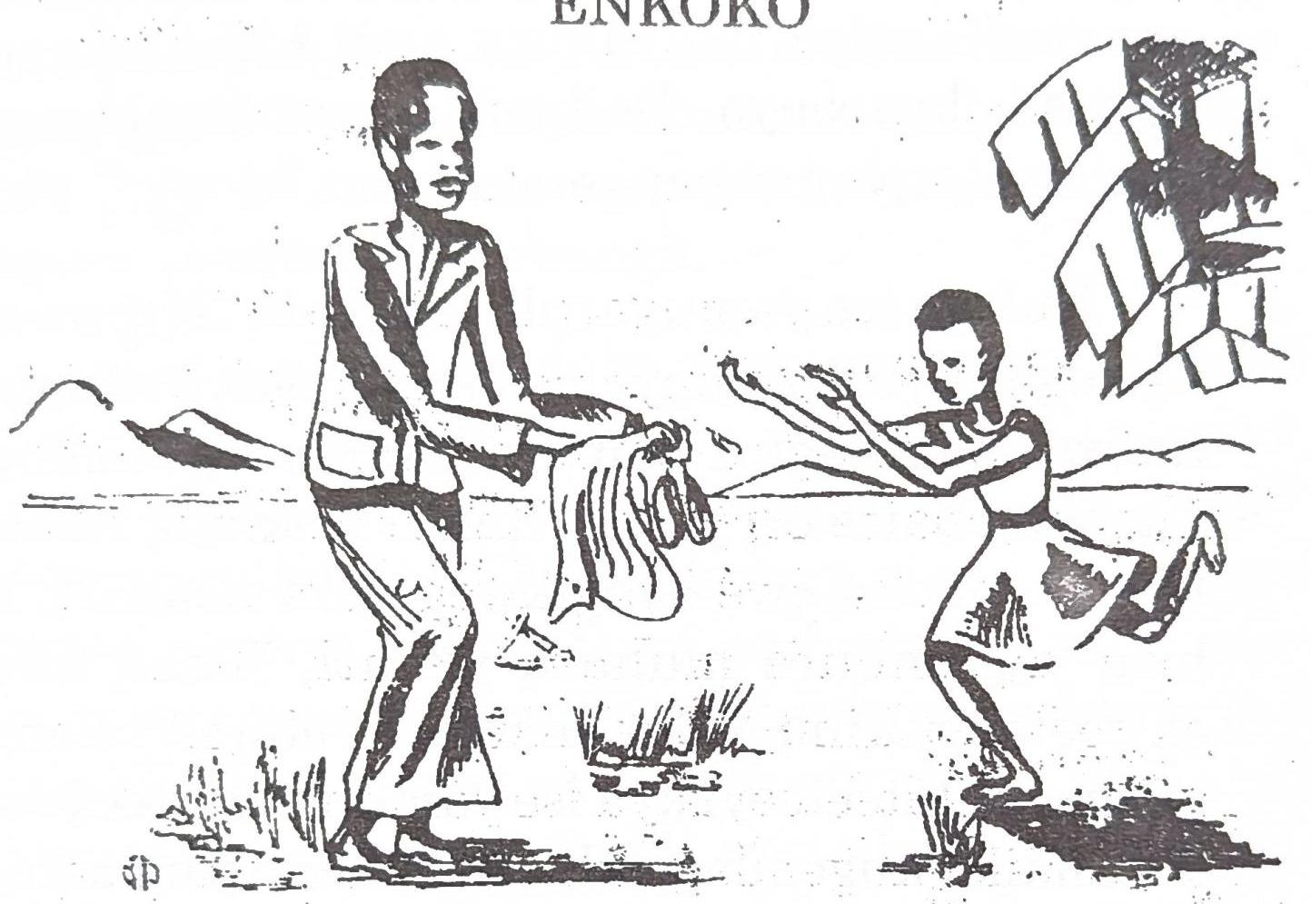

Omu biro bya ira hakaba haroho omusaija aina abaana be, aboojo bataano kandi abaisiki babiri omuhara we Banura, nuwe yakiraga boona oburungi n'amagezi.

Ekiro kimu, Banura akagonza kulya enyama, nubwo yaisire enkoko ye. Obu yamazire kugibaaga enyama yayó yagyahura, yabanza kugenda kuseenya enku z'okúcumbisa. Obu yagarukire omuka kucumba, akasanga enyama ye etali nambere yasigire yagyahura. Bambi, Banura yatandika

kurra! Ise, obu yahuliire omuhara narra, yataaha omu nju bwangu kwetegereza ekibaireho. Nubwo ise yamukagwize ati, "Abwooli norra ki?" Banura yagarukamu ise ati, "Nyisirege enkoko yange, enyama nasiga nagyahura omu kisiika kyange, nagenda kuseenya. Baitu obu ngarukire kucumba nasanga enyama yange etarumu."

Nubwo ise yamugarukiremu ati, "Nyowe nsangirege enyama ebinyomo bigijenjekere nibigirya, nubwo naginagira embwa. Mbaire ntamanyire nkooku ebaire eri yawe. Kandi n'ekindi, Abakazi tibalya nkoko; iwe ayagikwegeseza nooha?" Nubwo yagambiire muhara we ati, "Leka nkuhe ekiteeteeyi kinu. Eby'enkoko byebwe." Banura yatwara ekiteeteeyi kya ise yamuhaire, yakijwara. Yatandika kugendagenda omu maka, omu bataahi nukwo barole nkooku ajwaire kurungi.

Obu akaba akyali aho, yarora omusaija omuheesi, ahembere omurro naayota. Yamwirra haihi, yatandika kubaza na uwe. Hanyuma y'akasumi, oturo twamukwata, yagwijagira. Omu kusisiimuka Banura akasanga ekiteeteeyi kye akaba ajwaire atakyaina kyo. Ahonaaho yatandika kurra. Nubwo omusaija omuheesi yamukagwize ati, "Mwisiki iwe noorra ki?" Banura yagarukamu ati, "Ekitee-

teeyi kyange kimbuzireho." Omusaija omuheesi yamugarukamu ati, "Haroho ekiteeteeyi ndozirege hanu, nateekereza nti tikiina mugaso, hanyuma nakyokya. Kyonka kankuhemu endyamiti yange enu enungi ogitwale." Banura akaikiriza kutwara endyamiti. Hanyuma yasumurra ensahu ye yaihamu orugoye rundi yarujwara; yatandika kweyongera omu maiso kubunga.

Obu akaba yagendaho omwanya muke, yarora omukazi naaseenya, akwasire akahyo katoito muno nuko arukutemesa enku. Nubwo Banura yagambire omukazi ati, "Mukaikuru wange, kanooseenyesa akahyo enku! Dara endyamiti yange enu niyo oseenyese." Omukazi yasemererwa muno yatandika kuhinjura ekiti kikooto muno ekikaba kyomere kerekere. Baitu obu akaba yatemaho endemu emu yonka, yarora ebibbali byayo nibitaraaka omu mwanya! Nubwo omu kasumi ako Banura asaba omukazi ogu endyamiti ye enyakuhikiire. Uwe nubwo amugarukamu ati, "Tiinyina nambere nsobora kwiha endyamiti endi, kyonka tugende omuka nkuhemu obusera."

Banura akahimba obusera yabutwara. Obu yahikire haihi n'enyanja, yatuura ebintu bye, yagwa omunyanja okuziha. Obu akaba akyali omu maizi, embaata ikaija zaasoma obusera bwe. Obu

yarugire omu maizi, Banura yasanga embaata obusera bwona ibumazireho! Obu yazikagwize zaamugarukamu ziti, "Itwe tubaire tutamanyire obusera nkooku buli bwawe; habwokuba titukusangireho. Ebyaitu tulya titubirima: Kyonka katukuhemu ihuli limu." Banura yasemererwa, yagaruka omu maizi kuziha akwasire ihuli rye. Omu kasumi ako akarora encu nkooto omu maizi. Obu akaba naaserra kugikwata, ihuli lyamutaisuka omu ngaro, lyagwa omu maizi, lyayatika. Kycnka uwe encu yagikwata, yagitwara yagiguza omu katale. Sente ezi yaihire omu ncu yaiguzaamu enkoko endi. Enkoko ye akagirolerra kurungi muno hanyuma yayatira obwana ikumi, kandi bwona bwakura. Enkoko se zoona obu zaakuzire, yaiguza. Hati yagura embaata. Embaata na yo akagirunda kurungi yayalika amahuli kandi haarugamu embaata ezindi. Obu zaakuzire na zo yaiguza, ensimbi ezaazirugiremu yaiguzaamu entaama. Entaama obu yagigulize, sente zaayo yaiguramu embuzi. Embuzi ekazaara zindi ikumi. Banura yaiguza zoona, hanyuma yayegurraamu ente.

Ente egi ekazaara ezindi, kandi Banura ekamuleetera amagoba maingi; yafooka Mühumakati, yatandika kunywa amata gonka. Kuruga kasumi

ako, Banura yahanurra abaisiki bataahi be ati, "Kuba naliire enkoko yange eri tinaakutungire binu byona. Nahabweki kirungi itwe abaisiki okutalya enkoko, amata nugo tunywage."

# **VII**

## **HABWAKI ENGO BULI KASUMI IKWATIRA HA RUBAJU RW'EMOSO RWONKA**

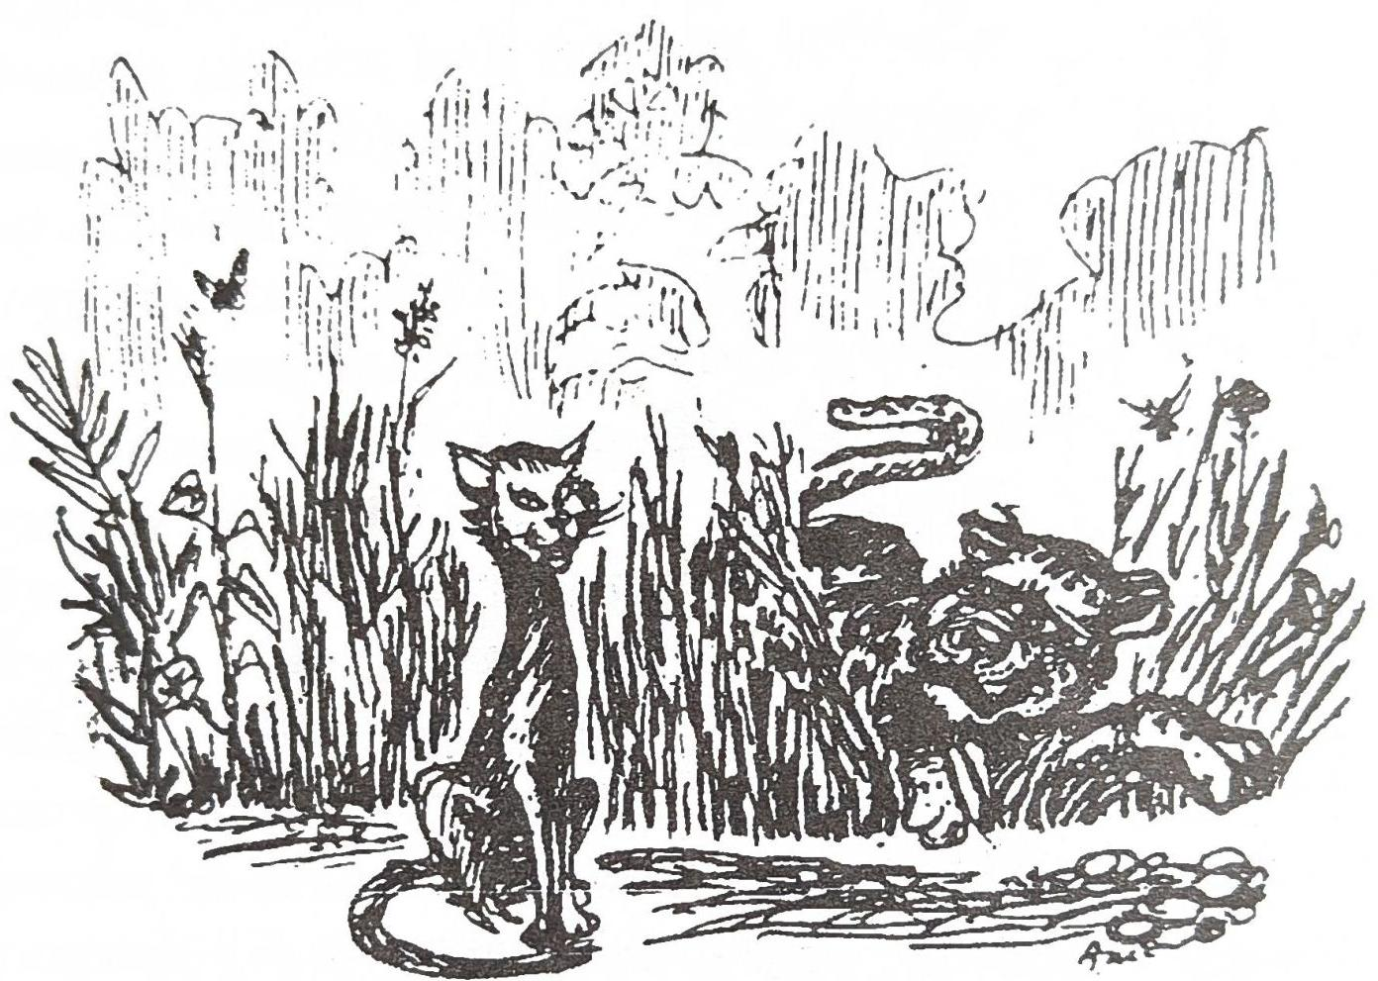

Kuruga kara, engo ikaba itamanyire kukwata ebisoro kubirya. Engo obu zaahuliire ngu Wanjangu amanyire muno kukwata, ikamugendera okutungayo amagezi. Wanjangu yazigamba ati, "Kirungi nyegeseeho engo emu, nukwo na yo eryegesa ezindi." Aho, Wanjangu yaragira Wango okwesereka omu kisaka ha muhandarubaju nukwo aleke okurorwa ebisoro ebirukurabaho. Ekindi Wanjangu yagambira Wango ati, "Osemériire

kumanya okusoobasooba nukwo ebisoro ebindi bireke kukuhurra bikairuka kakuba oba obihondiire okubikwata." Yayongera yamugamba ati, "Nkooku orukubanza kuhiiga, kirungiokukwataga enyamaiswa nooziruga ha bumoso. Hanyuma obu oraagenda nooyetegereza eby'obuhiigi, nubwo ndikwegesa okwikwatira ha bulye." Binu Wanjangu obu yamazire okubyegesa Wango, yamuraaliza bagende hamu okuhiiga. Omuhiigo gwa bo gukaba murungi; obu gwahoire, baayahukana, Wango yagaruka owaabu.

Kiro kimu, Wango akagenda kuhiiga wenka baitu atasobole kukwata. Enjara obu yamurumire muno, yaijuka nkooku Wanjangu akaba azaire abaana baingi; nahabweki yakwata ogurukugya owe. Omu kasumi ako Wanjangu akaba ataliyo, akaba agiire okuserra ebyokulya. Habw'enjara nyingi, Wango akeebwa embabazi za Wanjangu yamukoliire omu busumi obw'enyuma; yakwata abaana ba Wanjangu boona yabalya!!

Wanjangu obu yagarukire cmuka, aSerwire abaana be babuzire kandi arozire esagama ha kiikaro nambere Wango yabaitiire, yamanya nkooku abaana be baisirwe Wango. Ekyarugiremu nukwo Wanjangu okurahira ati, "Tindyongera kwegesa Wango okuhiiga n'amagezi."

Kurugiira aho engo ikalemerwa kimu okukwata ekisoro kyona ekiraba ha bulyo bwa yo.

# **VIII**

## **HABWAKI ENKOKO EKOOKA**

Ira muno, omurro gukaba gutarukuzooka. Izooba wenka nuwe yasoboraga okugutunga. Buli weena ayagwetaagaga yagusabaga kuruga omwa Izooba. Izooba akaba aina omuheereza we Wankoko, baitu yaikaraga naamujwahya kandi naamutalibaniza. Kyonka Wankoko akagumiisiriza okwikara na uwe, habwokuba obu yaakumwirukireho, Izooba yakusoboire kumwokya.

Izooba yanywaga amata kandi yagonzaaga muno kunywa enyungu ye enkooto.

Ekiro kimu, Izooba akasaba amata kunywa. Omu kasumi nuko kamu yaragira Wankoko okumurungira enyungu. Obu akaba naagimukwasa, yataisuka omu ngaro, yagwa hansi. Kinu kikabiihiza muno Izooba. Nukwo okuragira Wankoko akamugarukamu ati, "Mugole wange hati enyungu emazire kwatika." Izooba yamuragira n'obusobozi kugikoma. Ahonaaho Wankoko yaharruuka, yagwa hansi. Baitu akasanga enyungu eyatikire eri bibbali. Wankoko habw'okugonza kurangira mukama we enyungu nkooku eyatikire, akaku-

nkumura amapapa ge yakooka ati, "Kooko-ko-liiko." Baitu Izooba atahurre, habwokuba akaba ali haiguru muno.

Kuruga kasumi ako, Wankoko yagamba ati, "Ndaikaraga ninkooka okumanyisa Izooba eby'enyungu ye. "Egi niyo nsonga ekookęsa enkoko eti "Kooko-ko-lii- ko."

# **IX**

## **OMUHIIGI N'AKANYAMANKOGOTO**

Omuhiigi akagenda kuhiga omu kibira ekikoota muno; baitu atasobole kwitayo enyamaiswa yoona. Yayeyongera kuhiiga, baitu obu yagenzire omwanya mukooto omu kibira, akahika omu kicweka eki akaba atakahiigiramuga. Obu akaba akyali aho, yahurra iraka n'ekizina ekirumu ebigambo binu, "Omusaija nuwe ayehambiriza kukora buri kintu; ebintu tibiri nibyo ebimuhambiriza kubikora." Omusaija omuhiigi akahuliriza n'omutima gumu ekizina eki. Obu yalengeraho okuserra ekyazinaga akasanga akanyamankogoto nuko akaali nikazina kandi kakwasire n'endere.

Hanyuma omuhiigi yagarukayo omuka, baitu buli kiro yazindukiraga omu kibira okuhurra ekizina ky'akanyamankogoto. Ekiro kimu omusaija akasaba akanyamankogoto kukatwara omuka ye nukwo kaikalege nikamuzinira. Akanyamankogoto kamwikiriza kyonka kaamugambira kati, "Ndäaziniraga iwe wenka kandi tihaabehoga omuntu ondi weena araahurraaga ekizina kyange." Omusaija yakatwara omuka ye, hanyuma yayeta abantu boona aba ha mugongo yabamanyisa ati, "Ndeesire omuzini murungi ow'okwikara na uwe omuka yange."

Omukama w'ekicweka eki na uwe obu yahu. liire, akaragira bwangu okweta omuhiigi hamu n'omuzini we abarole. Omuhiigi obu yahikire omu maiso g'Omukama hamu n'akanyamakankogoto abantu boona bakahunirra kuhurra ngu akanyamankogoto nuko kaazinaga, kandi kunu ebiro byona ko tikamanya kuzina. Baitu omuhiigi akagumiza kimu ati, "Bakama bange, kakuba akanyamankogoto kalemwa kuzina, haakire nyowe baanyite."

Ahonaaho, omuhiigi yaragira akanyamankogoto katandike kuzina, baitu katasobole, noobukwakubaire okwesamya akanwa kwonka! Habweki omukama akaragira abantu be kwita omuhiigi, ahonaaho bamwita. obu bakaba baamara okumuziika bati, akanyamankogoto kaazina. Abantu boona baahunirra kardi baatandika okugambirangana bonka na bonka bati, "Mugenzi waitu akatubaliza amanan baitu dora hati, bambi tumazire kumwita."

Ahonaaha, akanyamankogotc kaabagambira kati, "Bagenzi bange omuhiigi oli ekifubiro nuwe yakyereetiire. Nyowe nkanga kuzina habwokuba nkaragaana na uwe kuta gambira muntu weena

ngu nyowe mmanyire kuzina, baitu uwe eki atakifeeho nahabweki na nyowe nkaleka bamwita."

Obu akanyamankogoto kaali nikatandika kugarukayo mu irungu, kakasaba abantu boona kuhuliiriza akazina kaako omurundi gw'akabiri kandi n'okwetegereza amakuru g'akazina ako kurungi. Nubwo kaazinire kati, "Omusaija nuwe ayehambiriza kukora buli kintu; ebintu tibiri nibyo ébimuhambiriza kubikora." 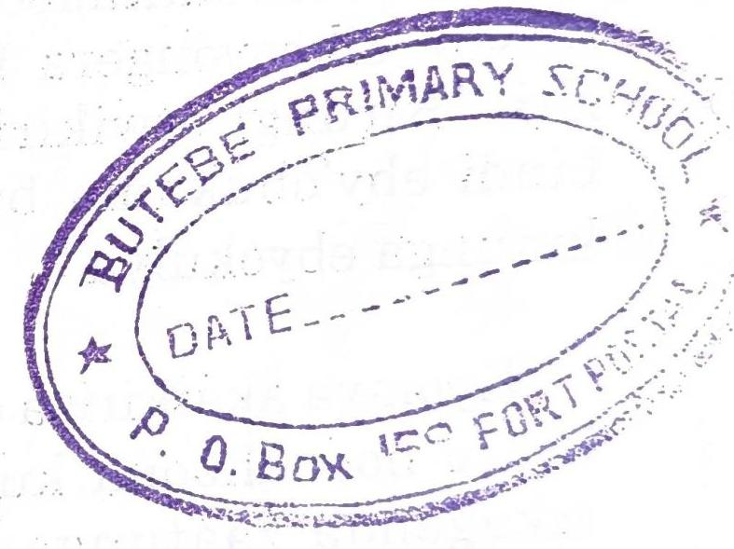

# X

# **X**

## **HABWAKI ENSERE ZIIKARA OMU MAIZI**

Hakabaho akasumi k'enjara, ensere ikaburwa ebyokulya zoona zaikara omu maka gaazo, zaategereza kufa kwonka; habw'enjara.

Kyomya nuwe yarolerraaga ensere,kandi nuwe akaba aina ebyokulya. Kiro kimu ensere zoona ikagenda hali mukama wazo zaamugambira ngu, "Kigambo ky'ensoni kurora iwe mukama waitu torukusobora okutukoonyera okutuha ebyokulya." Ensere zikeeyongera kugambira mukama wazo ziti, "Kirungi otwikirize tugende omu bicweka bindi eby'obukama bwawe, nambere tusobora kutunga ebyokulya."

Kyomya akaikiriza ensere zoona kugenda omu byaro hoonahoona kuserra ebyokulya. Ensere zikagenda zaatunga ebyokulya zaalya, kandi ebindi zaabiboha. Obu zaali niigaruka zaarora onurro nigwaka omu maiso nambere zikaba niigenda. Obu zaahikire haihi zaarora amaju gaazo gakwasirwe omurro nigahya. Zaalengaho okuguraaza baitu na zo zaahya obwoya bwa zo bwona bwazihweraho kimu, hanyuma zairuka zaayesereka omu kisaka. Haihi n'ekiikaro eki, hakaba haroho enyanja, nahabweki ensere ikagwa omu

maizi g'enyanja nukwo itunge okufukirirwa ha mabiri ya zo nkooku zikaba zimazire kwokebwa muno omurro. Kuruga kasumi ako zitongere kugaruka ha bwerre habwokuba zaateekerezaaga ziti omurro gukyaliyo ogw'okuzookya.

# **XI**

## **RWAKAIKARA OMUSOHI W'ENCU KANDI OMUFU W'AMAISO**

Rwakaikara, smu biro bye eby'obukuru, akatandika kukora omulimo gw'obusohi. Akaba yakoraho omulimo gunu'rumara obusumi buke, amaiso ge gaafa; baitu habw'okugumiisiriza, ataleke kukora omulimo gwe. Nalabweki akakoseza abasaija bandi babiri okumukzonyera. Abasaija abo baamugonzaaga kandi hamukoonyeraga muno. Bakaba bali beesigwa hali uwe. buli kiro, baamutwaraga omunyanja, bamita omu lyato kandi baamugambiraga okunaga akatimba ke. Baamumanyisaaga omulingo gw'okukanjurra kandi n'akasumi ak okukasika kuruga omu maizi. Obu baagarukaga he bwerre, taamukwatirraaga nukwo aleke kugaruka enyuma kugwa omu maizi.

Obusumi bwona baamukoonyeraga bati, baitu uwe tiyabasiimaga. Obu baamuhaburaga ha kunaga akatimba ke nukwo akwase encu, uwe yagarukamuga ati, "Mmanyire aho nuho ndukukanaga." Obu basmugambiraga kuruga omu lyato, uwe yabagarukamuga kubi ati, "Na nyowe mmanyire nkooka tumazire kuhika ha musa gw'enyanja". Nukwo baikaire na uwe bati kumara akasumi kakooto.

Ekiro kimu, bakagonza kumwoleka nkooku akaba naayebiihabiiha omu ebi yabagambiraga. Obu bakaba nibagwerra omu lyato na uwe baamugambira okwijamu. Habw'omugisa, Rwakaikara akakwatirra omu hali bo na uwe yagwa mu lyato. Obu baahikire omu maizi baayeteekaniza okunaga obutimba bwabo; hanyuma baamugambira ná uwe anage ake. Uwe yabagarukamu naabajuma ati, "Habwaki mwikaraga nimuntalibaniza n'okundagirra buli kintu, nyowe mmanyire ekindukokora." Abasaija abaakaba aina bo obu baaboine biri biti, baasorooza encu zaabu baazita omu bwato hanyuma baatandika kugoya obwato kugaruka omuka. Rwakaikara-Kihimbaara na uwe akaba aikaliiremu omu bwato baitu uwe akaba atakwasize encu n'emu.

Obu bakaba batakahikire ha musa gw'enyanja kuboha obwato kurugamu, baagambira Rwakaikara bati, "Weewe ruga omu bwato tumazire kuhika ha bwerre." Rwakaikara yabagarukamu ati, "Dora abadoma banu, obu muteekeriize muti nyowe timmanyire nkooku tumazire kuhika ha musa? Leka ndugemu nukwo mumanye nkooku ndukumanya." Ahonaaho Rwakaikara akagurukamu. Ntamanya akaba nayedikya omunyanja. Amaiso agaamurozire nugo ago. Rwakaikara

waawe akamirwa amaizi, gamwita! Yafa nk'abemyehahiro boona oku baba.

# **XII**

## **EKYOMA EKYASAAGA OBURO KYONKA**

Omu biro bya ira enjara ekagwa omu kicweka kya Bunyaruguru omu nsi y'Ankole. Omu ka emu, nyineeka Katabaazi n'abantu be badoodooka muno baija kwitwa enjara. baitu mwijukuru wa Katabaazi hamu n'abantu be bo baazookaga baina amaani kunu na bo baali bombekere haihi na Katabaazi. Omusaija Katabaazi akaba atamanyire nambere omwijukuru yaihaga ebyokulya; nahabweki yamalirra okumweserekerra nukwo arole nambere ebyokulya abiha. Katabaazi akalemwa kukenga omuhanda ogwatwaraga omwijukuru mu kisaka kuleeta ebyokulya. Nahabweki yatandika kumukaguliriza nukwo amumanyise nambere uwe atunga ebyokulya; baitu omwijukuru kubanza yahakanira kimu ati, "Tinyina hoona nambere nyiha ebyokulya. Na nyowe enjara yookunyita."

Baitu Katabaazi akeeyongera kumukaguliriza kuhikya obu yamujwahize; nubwo omwijukuru yamugambira ati, "Obu nkaba ningendagenda omu irungu nkarorayo ekyoma kikooto ekisa oburo kyonka. Buli kiro kisa ebigega bibiri, kandi kibyahura kurungi. Nyowe ngendayo ekiro nimbutabarra." Katabaazi obu yahuliire ebigambo ebi

yayesengereza muno omwijukuru na uwe amutwaleyo; baitu omwijukuru akabanza kwangira kimu. Katabaazi yanwikaraho muno kuhikya obu yaikiriize okumutwara kumwoleka ekyoma.

Obu baahikireyo, bakasanga oburo oburukwijuza ebigega bibiri bumazire kuteekanizibwa. Katabaazi obu yaboine kinu ekyakaba atakabonaga, yagambira omwijukuru ati, "Nyowe ekyoma kinu ningonza kukitwara omuka yange, habwokuba tiinyina maani g'okwijaga kunu buli kiro kutabarra oburo." Baitu omwijukuru yahunirra habw'okuhurra Katabaazi nabaza ebigambo biri nk'ebi. Nubwo yamukagwize ati, "Iwe kinu kyoma kyawe, rundi kyange?" Baitu eki Katabaazi atakigarukemu, uwe akamara gahimba ekyoma yakigagaaza kukireeta omuka ye. Katabaazi n'omwijukuru baakirwanira baitu hab'wamaani, Katabaazi yasingura yakyetweka kukitwara.

Ekyoma kikagenda nikimuteera omutwe baitu uwe atahuliirize. Obu akaba ali haihi n'okutaaha, ekyoma kyamubundikira kimu kyamuteera hansi kyamucwacwana weena. Kyamwita. Aho okufa kwa Katabaazi nuho kwarugiriire habw'okunyaga eby'abandi.

# **XIII**

## **JUMA N'ABAKAZI ABADOMA**

Omu biro bya ira, omusaija Juma Omusiraamu akaswera omukazi ou akaba atali Musiraamu. Ekiro kimu, Juma akagenda omu katale yagurayo ebyokulya ebya buli mulingo, yabireeta omuka yabikwasa mukazi we ati, "Nyowe nyina orugendo rwange orundukwija kugenda orw'ebiro bitaano. Ebyokulya byona ebi nguzire obyahule kurungi by'obugenyi bw'Aramanzaani."

Mukazi we akaahura ebintu byona ebyaguzirwe iba omu kisiika kimu, yabirinda kurungi nkooku iba yamuragiire. Ebiro bibiri obu byahingwireho, omukazi wa Juma obu akaba aikaliire omu nju akahurra omuntu naayeranga ha rwigi. Obu yakingwire orwigi yasangaho omusaija, yamutangirra, yamuramukya. Omusaija yakaguza omukazi nambere iba akaba agiire. Omukazi yasoborra omugenyi ati, "Juma akabunga, naamarayo ebiro bitaano." Omugenyi hanyuma yaraga omukyara ati, "Ogire musana." Nubwo omukyara yamukagwize ati, "Omunyoro obu aligaruka ndimugambira nta?" Nubwo omusaija yagarukiremu ati, "Olimugambira oti munywani waawe Aramanzaani nuwe akaba aizire kukurora baitu tiyakusangaho." Omukazi obu yahuliire eby'omugenyi yamugambiire, ahonaaho yamugamba ati, "Caali

niiwe Aramanzaani! Iba nyowe akasiga yakugurra ebintu bingi hanu, leka mbikuhe." Omusaija óbu yahuliire ati yasemererwa muno. Omukazi yamuha ebyokulya byona ebi akaba ayahwire., Hanyuma omusaija yagarukayo owaabu.

Ekiro obu kyahikire, Juma yagaruka, naaruga nambere akaba abungire. Mukazi we obu yamazire okumwihurra ebyokulya, amazire n'okulya, yamungambira ati, "Munyoro, enganjani yaawe Aramanzaani akaija hanu kukurora, baitu akasalirwa okutakusangaho. Kyonka ebintu bye byona ebi wansigiire nkabimuha, kandi akakusiima muno." Juma yarora mukazi we n'amaiso g'okuhunirra; yamukaguza ati, "Omusaija Aramanzaani ou orukungambira wankaha nyowe ou ntamanyire. ogu?" Juma obu yagenzire omu kisiika yasanga ebyokulya byona ebi akaba aguzire bitaliyo. Ahonaaho yakwata empirima ye yagonza kwita mukazi we. Omukazi yatandika kurra muno, nahabweki iba yamukwatirwa embabazi yaleka kumwita. Juma yagambira omukazi we ati, "Mukyara, leka kurra, huumura, hati kambungebunge hoona omunsi nyetegereze obu haraaba haliyo abakazi abandi abadoma nka iwe, Obu ndibasangayo na iwe tindikwita baitu obu ntalibasangayo ndikwita." Juma yakwata omuhanda

yagenda kuserra abakazi abadoma abarukusisana nka mukazi we. Obu yarubasire omwanya mwingi, yahika ha kasozi karungi nambere hakaba hali ekikaali ky'Omukama. Juma yayegoonya haihi n'ekikaali eki, yaraaraho.

Nyenkya, Juma na nyineeka obu bakaba nibalya hamu, Juma akagamba ati, "Ningenda kurora Omukama wa kunu, nyina obuzaale na uwe." Nubwo Juma yakagwize omusaija ogu, munywani we, kumugambira ibara ly'Omugo hamu n'amabara g'abazarraani be boona abaafire ira. Munywani we yamusoborra ibara ly'Omugo n'amabara g'abanyabuzaale b'Omugo ogu boona. Aho nubwo Juma acwa amagezi ag'okubanza kwehandiikisa amabbaruha omu mabara g'abazarraani b'Omugo ogu, hanyuma nukwo aimukyeho. Obu yayetegeriize kurungi enju y'Omugo nambere ekaba eri, akajwara obutengo yatandika kulima orwina nukwo aturukire omu nju hoonyini nambere Omugo akaba aikaliire. Juma akatalibana muno, empiita yamwiha kunu yamuta kunu, kuhikya obu yaturukiire omu kisiika nambere Omugo akaba aikaliire naatuka enkwanzi. Omugo obu yaboine omuntu naakukura hansi, yacwekwa enkinzi, yaburwa n'ekyokukora! Ahonaaho, Juma yaihayo amabbaruha ge gali aga akaba asiigire itak, yaga-

kwasa Omugo, kandi yamugambira ati, "Mugole wange, leka kutiina, nyowe ninduga okuzimu, ntumirwe so na nyoko, na bagenzi baawe boona abaafire okukuramukya. Hati soma amabbaruha ago orole ebi bahandiikiremu." Omugo obu yahuliire ebigambo bya Juma yasemererwa muno, yateekereza ati abantu be boona abaafire ira bakyaliyo boomeezi. Atamanye nkooku amabbaruha ago gaali gahandiikirwe Juma wenka.

Omwanya muke obu gwahingwireho, Juma yaraga Omugo kugarukayo okuzimu, baitu Omugo ahonaaho yaleetera Juma ebyokulya. Yamuha n'engoye zoona eza iba, kandi yaroramu engoye ezimu eze, yaiha Juma okuzitwarra nyina. Ebi obu byahoire, Juma akagaruka hansi omu kiina nambere yaleesirwe nubwo Omugo yaswekeriireho itaka, ebirago n'enkeeto.

Juma obu yaturukire aheeru y'ekikaali, yairuka yakwata omuhanda gw'ekisaka kuhikya obu yaigukiire omu muhanda gwonyini ogwamuleesire. Obu akaba akyali omu muhanda naagenda, yarora omukaikuru naalima ha muhandarubaju, yamugamba ati, "Mukaikuru weebale.Iwe obu kunu halima abakazi? Owaitu nambere narugire halima abasaija bonka." Juma akeeyongera yagambira omukaikuru ati, "Leka nkuhe ekanzu

yange enu niyo ojwale, na iwe ompe ekiteeteeyi kyawe, kandi ebintu binu obite hansi y'omuti guli, iwe ogutembe." Juma akagamba binu habwokuba akaba naayekenga ngu rundi Omukama nambere yarugire kubiihabiiha Omugo akaba naija kumuhondera. Obu bakaba bakyali aho, baarora omuserukale w'Omukama aizire bwangubwangu. Omuserukale yayeemerra yagambira Juma ati, "Iwe omukazi arukulima lekeraaho kulima. Omboniire amusaija naaraba hanu ayetwekere ekitambsara ky'engoye?" Nubwo Juma yagarukiremu omuserukale ati, "Mukama wange, omusaija ou rrukukaguza nguli atembere omuti. Ebintu bye abisigire hansi." Aho omuserukale asemererwa muno yayanguha kuhika ha muti, kandi yatandika kugutemba. Juma obu yaboine omuserukale naatemba omuti kukwata omusuma, yairuka bwangu, yakwata ekitambaara kye eky'ebintu yairuka yagenda. Omuserukale obu yasimburukire hansi yarora Juma nairuka akwasire ekitambaara, ahonaahoo omuserukale yatandika kumwirukya, baitu obu akaba naamwirukya yagwa, yasaasa muno. Baitu uwe Juma yairukira kimu naagamba ati, "Kucweke nteho ekiti." Yakika omu ka ye. Juma akaba amazire kutunga eki yaserraaga. Akasanga abakazi abandi abadoma abaasisanaga n'omukazi we. Nahabweki, eki kikakiza mukazi we kumwita.

Kuruga akasumi ako, akateererra mukazi we kwerindaga n'okuteekerezaaga muno atakakozere kintu kyona.

# **XIV**

## **OMUNYORO TINDUKWETEGEREZA**

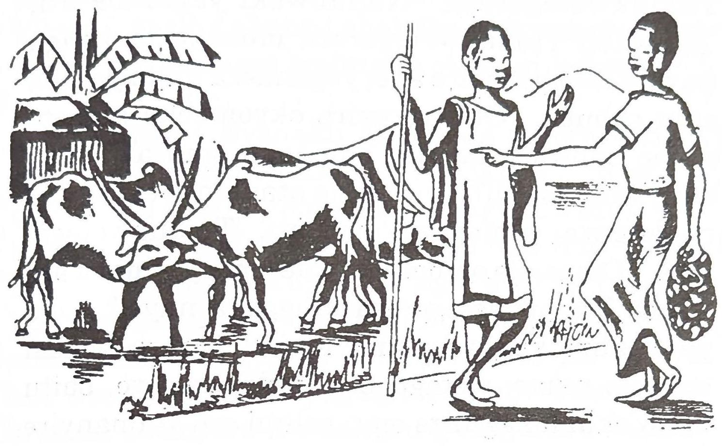

Kiro kimu omusaija Byenaku obu akaba naagenda omu rubuga rwa Bunyoro orwetwa Hoima, akatunga obulemeezi omu ruhanda rwe habw'okutamanya orulimi orw'abantu baayo baabazaaga. Uwe akaba amanyire orulimi Oruganda orwabazibwaga ha kyaro ky'owaabu. Obu akaba ali haihi kuhika mu rubuga, akarora igana ly'ente niirya. Yahunirra habw'oburungi bwazo, yakaguza omuliisa wa zo ati, "Ssebo zino ente zaani?" Baitu omuliisa w'ente atasobole kwetegereza orulimi orw'omuhinguzi yabalize, nahabweki akamugarukamu ati, "Tindukwetegereza."

Omu kasumi ako Byenaku uwe akateekereza ati rundi ibara lya mukama w'ente ezi nuwe yali Tindukwetegereza. Nahabweki yagamba ati, "Omwami Tindukwetegereza musajja muggaga nnyo!" Obu yarugire aho, yagendera kimu yahika omu rubuga. Obu yarozire ekyombeko kikooto muno nabwo yakaguza omusaija omu ati, "Eno ennyumba yaani?" Omusaija atamanye eki akaba naakaguza, yamugarukamu ati, "Tindukwetegereza." Omusaija omugenzi yahunirra yagamba ati, "Onno Tindukwetegereza muggaga nnyo." Obu yayongiire kugenda omu maiso, yarora bbaasi enkooto muno, yakaguza omubingi wa yo, baitu habw'okumukaguliza omu rulimi oru atamanyire na uwe yamugarukamu ati, "Tindukwetegereza". Omu kasumi ako nabwo Byenaku yagumya ati, "Bbaasi egi na yo y'omusaija Tindukwetegereza".

Omusaija ogu Byenaku obu yamazire kugura ebintu ebi akaba aiziriire akagaruka owaabu. Obu akaba atakataahire, yatangatangana abantu beetwekere omutumbi, abamu bakaba nibarra muno. Byenaku yabakaguza ibara ly'omuntu anyakufiire. Omuntu omu ateetegereze ekigambo kya Byenaku nahabweki yamugarukamu ati, "Tindukwetegereza." Byenaku obu yahuliire ati, ahonaaho yanaga ebintu bye, yatandika kurra muno. Akateekereza

ati omusaija omuguuda muno ou akaba atungire itungo lya buli mulingo, nuwe akaba afiire. Omu kasumi ako yakwata omu nsahu ye yaihamu siringi kikumi, yaziha abantu abakaba beetwekere omutumbi kuziguramu embugo z'okuguziikamu.

Hanyuma Byenaku akagenda mpora yahika owe. Yagambira mukazi we nkooku ebintu byona omu tauni byali by'omusaija omuguuda muno Tindukwetegereza, baitu omusaija ogu hati afiire. Kandi yayongera kugamba ngu uwe talyongera kugaya ebintu bye ebike ebi aina, ngu habwokuba noobu araatunga bingi nabwo ali w'okufa. Baitu abo abaahuliire ebi yagambire habw'okumanya orulimi Orunyoro n'amakuru g'ekigambo "tindukwetegereza," bakasekeereza muno Byenaku habw'obudoma bwe.

# **XV**

## **EKISURA EKYAIBIRWE**

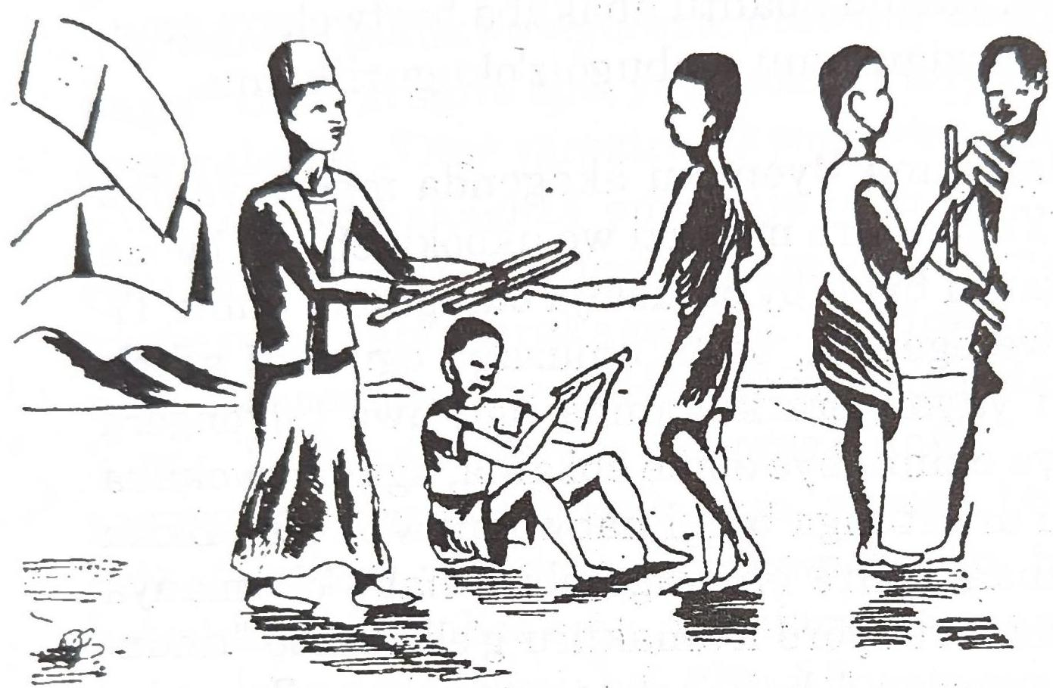

Ira muno hakaba haroho omusaija ayasuuburaga ekisura omu kiikaro kya Kinkizi. Ekiro kimu hakaija omusuma omu mwirima, yatema enju y'omusuubuzi ogu, yaibamu ensaho emu y'ekisura. Omusaija onu omusuubuzi ayayetwaga "Muguuda", akagenda bwangu yarangira omunyoro we owa ha kyaro nkooku ensahu ye emu ey'ekisura yali ibirwe. Omunyoro akasorooza abantu be boona yabamanyisa ati, "Ensahu emu ey'ekisura kya Muguuda bagiibire omu nju ye ekiro. Busaho kugurukyagurukya, ekisura eki kiibirwe omu hali

inywe. Hati ningonza ogu ayakiibire ayerange." Baitu busaho n'omu ayasoboire kwegamba hali omunyoro. Nubwo abantu baahanwire bati, "Kirungi tuserre amagezi goona agaraatukoonyera kumanya omuntu ogu."

Nubwo omunyoro yayemeriire hagati omu bantu be yarangiira ati, "Omuntu weena araayegamba wenka ati, 'Niinyowe naibire ekisura' araaheebwa ekisembo." Baitu nabwo busaho n'omu ayasoboire kwimuka akeegamba wenka nkooku yaibire ekisura. Nahabweki omunyoro akateekereza muno, yaimuka yagambira abantu be ati, "Hati ncwire obuti bunu kandi bwona bwina obura bwa fuuti emu buli kati? Omu kasumi kanu, ningenda kubagabira obuti bunu, buli omu omuli inywe araatwara akati kamu. Nyenkya inywena mubugarre hanu. Ogu aliba aibire ekisura, akati ke nikaija kuraiha kweyongeraho inci emu."

Omunyoro akagabira abantu boona obuti obu, hanyuma baagarukayo omu maka gaabo. Omusaija omu ayayetwaga Timbigamba, ou akaba aibire ekisura, obu yataahire omuka, yatandika kutiina n'okutukumira. Yagamba ati, "Leero nkole ki? Akati kange omunyoro akampaire nikaija kuraara nikakura; nahabweki kancwe amagezi nkakoneho akacweka akaakweyongiireho." Omu

kasumi ako nubwo aomusaija Timbigamba akwata omuhyo gwe akona akati akayahairwe omunyoro. Obwire obu bwakiire Timbigamba n'abantu abandi boona baagenda omu rukurato nkooku omunyoro waabo akaba abaragiire. Obu bamazire kwesoroza boona, omunyoro yatandika kulenga obuti. Obu yahikireho Timbigamba, akasanga akati ke kagufuhaire katarukwingana n'obwabandi, nahabweki omunyoro yarangirra hali abantu boona ati, "Timbigamba nuwe yaibire ekisura kya Muguuda."

Abantú boona baatandika kusekeereza Timbigamba bati, Obusuma bwe!" Kandi omunyoro yaragira omusuma ati, "Garraayo bwangu ekisura kya Muguuda omwesengereze akuganyire; kandi hati obanze ogambire abantu boona omu rukurato runu oti, 'Mpemukire kuba musuma. Tindyongera kwiba ekintu kindi kyona ekya mutaahi wange'." Timbigamba nukwo yakozire. Okuruga obu akafooka musaija murungi kandi w'omugaso omu bantu abayaikaraga na bo.

# **XVI**

## **OMUKAIKURU N'ENTE YE**

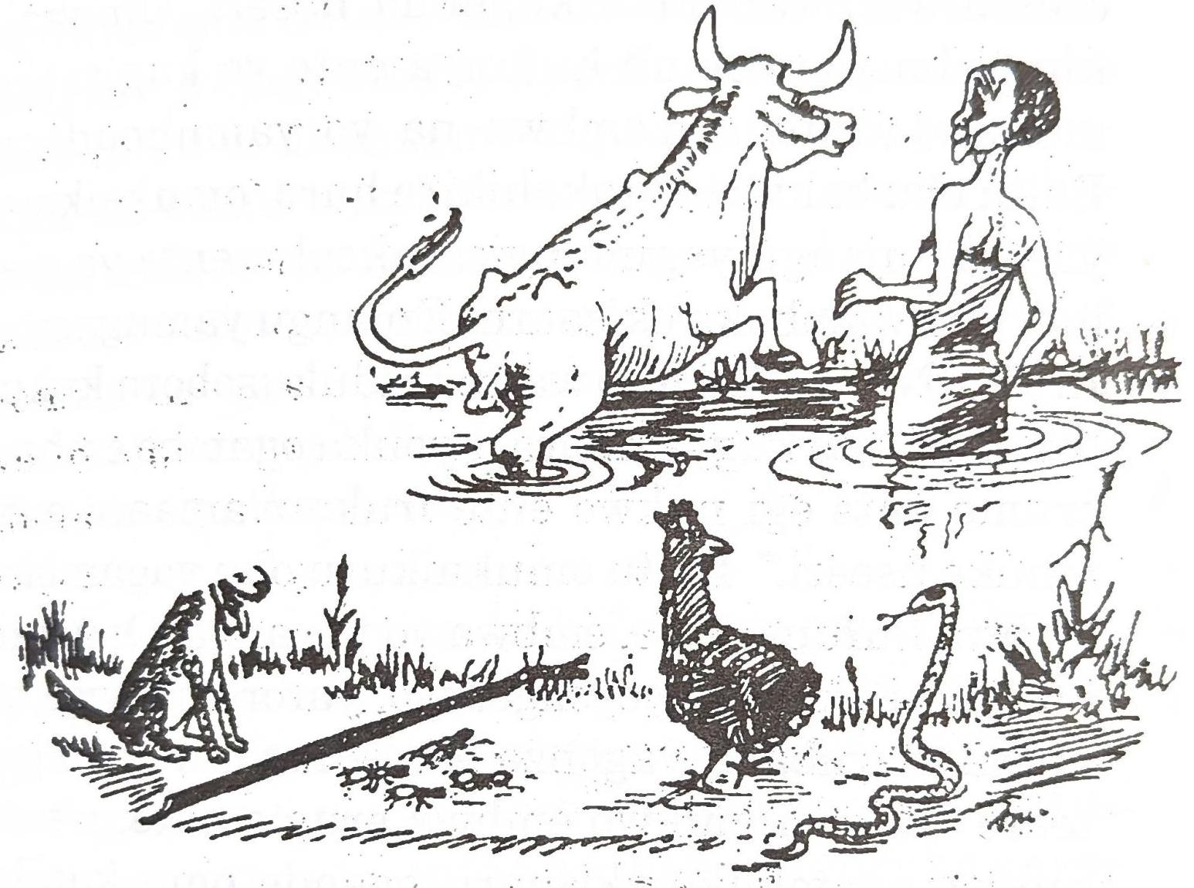

Hakaba haroho omukaikuru ou akaba aina ente ye emu. Ekiro kimu yagonza kugiguza nahabweki yagifunya kugitwara omu katale. Obu yahikire ha kyambu, ente etasobole kwambuka. Kinu kikaleetera omukaikuru kutalibana muno habw'okurabya ente ye omuhanda ogwa hara ogw'obwerre bwonka. Omukaikuru yatuntura yateekereza ati abasuubuzi b'ente naija kusanga baguzire ente zindi.

Omukaikuru obu akaba akyali aho naateekereza eby'omuhanda, yarora embwa. Na yo ekaba eremerwe kwambuka kugenda nseeri. Omukaikuru obu yacwiremu kufunya ente ye kugirabya muhanda gundi, n'embwa na yo yamuhondera. Baitu obu bakaba batakahikire hara, omukaikuru yarora enjangu yagimanyisa nkooku ente ye eremerwe kwambuka ekisaaru. Enjangu yamugambira eti, "Nyowe ndi murwaire tindukusobora kukuhimbisa ente kugyambura, kyonka ogambe embwa erume ente egi nukwo ente iruke n'amaani eyambuke nseeri." Baitu omukaikuru obu yagambire embwa kuruma ente, embwa yo yayanga. Omukaikuru obu akaba yayeyongerayo, yarora omwigo ha muhandarubaju, yagonza kugwihayo nukwo guteere embwa, nukwo embwa erume ente, n'ente nukwo eyambuke ekisaaru egende omu katale. Baitu omwigo gwayanga.

Omukaikuru yabiihirirwa kimu habw'okurora akeereriirwe kuhika mu katale mu kasumi koonyini. Baitu ahonaaho akarora enkubebe, yaziragira kuruma omwigo nukwo na gwo guteere embwa, embwa erume ente, nukwo n'ente esaalirwe, eyambuke ekisaaru. Enkubebe zitaikirize kuruma omwigo. Baitu omukaikuru akeeyongera kugenda omu maiso; hunyuma yatangaana enkoko. Yagye-

sengereza ikirize esome enkubebe nukwo na zo zirume omwigo, omwigo guteere embwa, nukwo n'embwa erume ente iruke eyambuke ekyambu, agitwale omu katale. Enkoko etahuliirize eby'omukaikuru yagigambire; kyonka omu kasumi ako omukaikuru akanagira enjoka amaiso, yagyesengereza eteme enkoko nukwo enkoko esome enkubebe, enkubebe irume omwigo, nukwo omwigo guteere embwa, embwa erume ente, nukwo n'ente esaalirwe eguruke eyambuke ekisaaru, nukwo omukaikuru agihikye mu katale agiguze bwangu akatale katakaabwire.

Enjoka yaikiriza kukoonyera omukaikuru. Ahonaaho yakwata enkoko, enkoko na yo yatandika kusoma enkubebe, enkubebe zaaruma omwigo, omwigo gwateera embwa, embwa yaguruka yaruma ente, ente ahonaaho yaguruka yayemiisa nseeri y'ekyambu, n'omukaikuru na uwe yayambuka; kandi yasiima muno enjoka okubanza. Hanyuma yahikya ente ye mu katale yagiguza; byona byahwa kurungi.

# **XVII**

## **OBUCWANGYA BWINGI BUKAFEEREZA KATABAAZI ENJOJO**

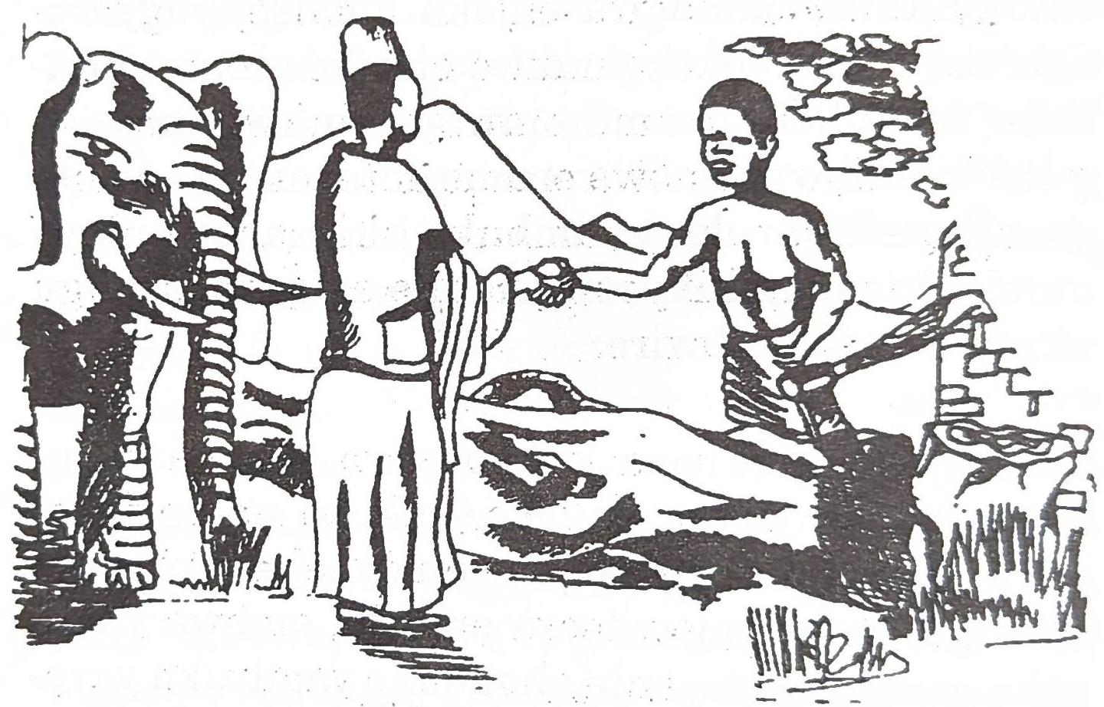

Omu biro bya ira hakaba hakuzire omuti mukooto muno haihi n'ekikaali ky'Omugabe. Omuti ogu gwasiikirizaaga abantu b'omu kikaali okutarora kurungi ebintu ebya hara. Na habweki Omugabe akasorooza abantu be yabamanyisa ati, "Omuntu weena ou araatema omuti gunu akagunaga hansi n'endyamiti y'ekiti etali y'ekyoma, ndaamuha ekisembo ky'enjojo eyemeriire." Abantu boona baatiina kwikiriza obu baahuliire Omugabe naagamba kutemesa omuti endyamiti y'ekiti:

Omusajja omu, ibara lye Katabaazi, akaikiriza kulengaho kutema omuti ogu. Nahabweki Omugabe yaragira abagaragara be kuha Katabaazi endyamiti y'ekiti n'omuntu omu ow'okumurolerra nkooku arukutemesa endyamiti ei baamuhaire. Ahonaaho Katabaazi yatandika kutema omuti, baitu naateekereza muno amagezi agaaraacwa okweihaho omusaija ayamulindaga. Nubwo yamubiihabiihire bwangu ati, "Awe, Caali dora enimi y'empara yacwanganiza hali, gihondere ogicumite."

Omusaija obu yahuliire ati, ahonaaho yasomora icumu lye yakwata enkiro ei Katabaazi yamwolekere yahondera empara. Katabaazi obu yaboine omusaija ahweriireyo, yaihayo endyamiti ye ey'ekyoma ei akaba aserekere, yatandika kutema omuti bwangu-bwangu. Obu yarozire omuti guli haihi kugwa hansi, yalekeraaho kutema, yasereka endyamiti ye ey'ekyoma, yaikarra kuhuumura naalindirra omusaija oli ayamulindaga kugaruka, nukwo anage omuti na uwe naarora. Hanyuma y'okuhondera empara ei ataraboineho, omusaija akagaruka ajwahire muno. Katabaazi akamuganyira habw'okujwaha ati, atagiisire. Ahonaaho Katabaazi yakwata endyamiti y'ekiti omungaro ze yasonga omuti gwagwa hansi guti "bbu". Omusaija

na Katabaazi baagenda baamanyisa Omugabe nkooku Katabaazi omuti agutemesese endyamiti y'ekiti yagunaga.

Omugabe akasiima muno Katabaazi kandi yamugabira enjojo nkooku akaba amuraganiize. Katabaazi yasemererwa muno yatandika kufunya enjojo ye kugitwara owe. Baitu obu yahikire omu muhanda yateekereza ati, "Obu ndaatwara enjojo enu omu ka, nkagiita, abantu baingi nibaija kwija kunsaba enyama nibagiimaraho, na habweki kampiige akasoro akatoito nuko ntwale omuka, enjojo nsige nagisereka." Katabaazi obu akaba naateekereza ebi, yarora endahi neesoma mu musiri haihi n'omuhanda. Yasemererwa ati, "Otyo kankwaté endahi enu niyo ntwale omuka". Ahonaahó Katabaazi yasiga enjojo yonka yairuka kuhambya endahi. Endahi obu yamuboine ekairuka yayongera yaharruka yamusiga.

Katabaazi obu yagarukire kurora enjojo ye nambere yagisigire, akasanga na yo irukire etaroho. Katabaazi akagiserra yaburra kimu. Nubwo yagarukire omu ka ye abiihiirwe. Mukazi we akaba amazire kuhura nkooku iba yahairwe Omugabe enjojo habw'okutema omuti akagunaga n'endyamiti y'ekiti, nahabweki akaba asiire oburo ateekereho enyungu alindiriire iba kuleeta enjojo

kugigaba nukwo bacumbire abantu obugenyi. Baitu obu baamusiimire omu irembo Kataabazi ebyara yabita omu nyindo yahungya omutwe ati, "Mundeke kwonka, enjojo enyirukireho, amagezi gange naacwire gakafa busa."

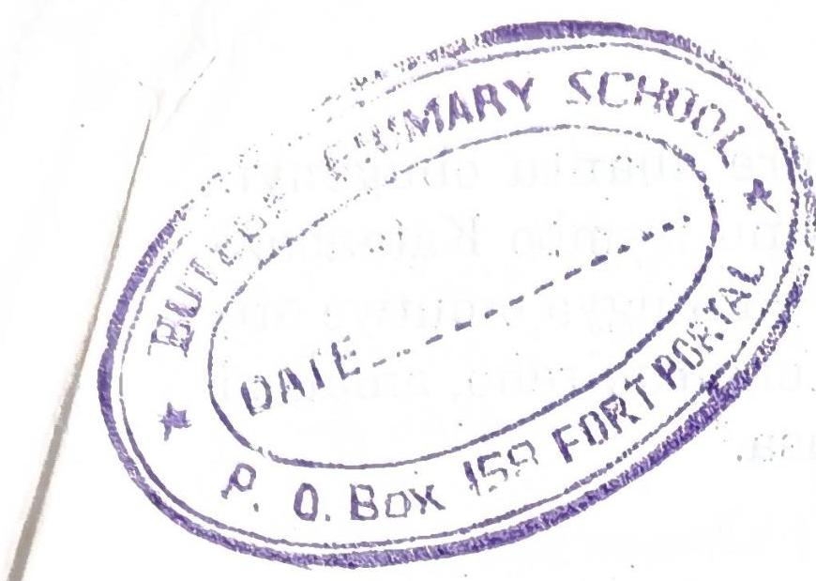

PRINTED BY SAPOBA BOOKSHOP PRESS LTD.